AHRQ Eisenberg Center (EC)
Option Year 2
Baylor College of Medicine Overview of Proposed Project Work Plan (PWP)
Budget and Planning Assumptions

This document provides a high level overview of the proposed project work, budget allocation, and planning assumptions by Task for Option Year 2 (OY2), should the Agency for Healthcare Research and Quality (AHRQ) decide to exercise the option year contract. A contract modification was executed on May 19, 2016, which included the removal of Task 5 (White Paper Meeting) from OY2; thus, this task is not reflected below. Further, per instructions from AHRQ in October 2016, the Task 4 (Decision Aid) work under OY1 for the development of the Breast Cancer Screening Decision Aid will be continued and completed in OY2; thus, this work is included below.
Task 7: EHC Program Web Site
In brief, the major activities of Task 7 in OY2 include the implementation of the overall plan for Web site revision including the following (see anticipated timeline and narrative below).
OY2 ANTICIPATED TIMELINE
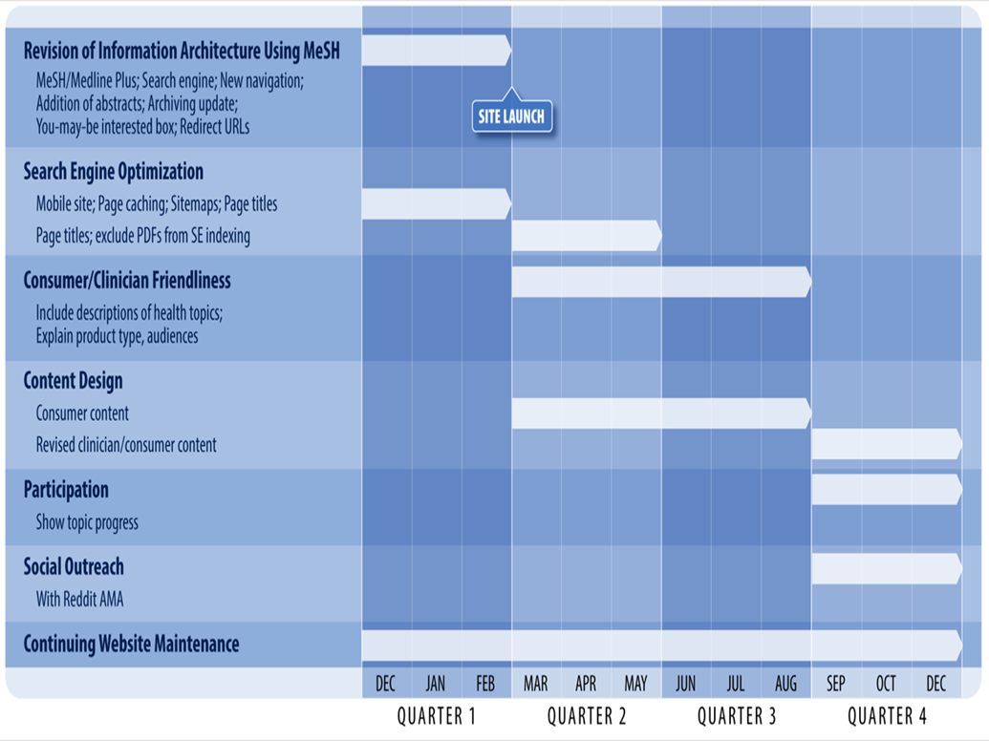

QUARTER 1 (Goal - Launch of New EHC Web Site)

Revision of information architecture using Mesh to categorize all reports and products, improve mobile site, and initial search engine optimization for Launch.
  - Homepage redesign – Develop a new homepage design informed by AHRQ review and user testing of at least 3 design concepts. Employ user-centered design and usability best practices to optimize for user experience and functionality.
  - MeSH / Medline Plus -Map MeSH to Medline Plus concepts for initial launch.
  - Search engine - Integrate new search engine and make initial adjustments on search algorithms and facets for review by AHRQ. Adjust accordingly.
  - New Navigation - Develop and deploy new navigation for AHRQ review employing a series of facets across HEALTH TOPICS, CONSUMERS, BROWSE TOPICS that will provide alternative avenues for identifying products, reports, and tools across AHRQ database. Adjust accordingly. Create new navigation for RESOURCES & TOOLS, METHODS, PARTICIPATE.
  - Addition of Abstracts – In response to a request from AHRQ, add an HTML abstract or exerpt of the document opening (250 words) to documents/reports currently displaying only a link to the PDF where possible and appropriate. The abstracts or opening words will be used for indexing. Conduct a review of all product types to determine appropriate content to include will be necessary. Additional review by AHRQ will be necessary.
  - Archiving update - Document and implement AHRQ policy for archiving and display of materials deemed out-of-date, including policies for handling in searching and filtering.
  - You-may-be interested box – Provide related resources on each page that provides users with additional materials.
  - Redirect URLs – Create redirects for each current page to the new site URLs for those using older links.
  - Simplifying Search Returns and Product Listings – Develop alternative view that does not display protocols and disposition documents for completed reports in search returns. These documents will be shown only as PDFs in association with the complete report and executive summary.

- Search Engine Optimization
  - Mobile site - Optimize the site display for use on mobile platforms. This will help many consumers who may access the site primarily via mobile and will improve search engine rankings (mobile friendliness is an important signal for Google ranking).
  - Page caching - improve the page load speed (and reduce hosting costs) for the website. Page load speed is an important signal for Google ranking and a significant factor leading users to abandon a site.
  - Sitemaps - provide a machine-readable sitemap to inform search engines about the structure of the site and other metadata to allow them to crawl more efficiently and effectively. While this does not directly affect rankings, it can ensure that all content is crawled and indexed appropriately.
  - Page titles - ensure that all pages have informative, appropriate page titles. Google (and other search engines) use the page’s title attribute to build the search result and a relevant title is a very important signal in result ranking. These are done well in the current site but have not been implemented in the beta site.
- Ongoing review and approval of site design and implementation
- Completion of 508 compliance review
- Launch of EHC site
QUARTER 1 WORKING DRAFT TIMELINE
Timeline dates are contingent upon meeting projected development and review schedules. Unanticipated changes in site design or scope may affect future delivery dates.
12/16/16 | Complete candidate homepage design concepts
 | AHRQ review of homepage designs (EC to receive comments by 12/23/16)
 | Begin user testing for homepage designs
12/23/16 | Complete Health Topics and Browse Products page design
 | AHRQ review of Health topics and Browse designs (EC to receive comments by 1/6/17)
1/6/17 | Develop final homepage design based on AHRQ comments and user testing
1/13/17 | Eisenberg Center internal review of Consumer, Research & Tools, Methods, and Participate pages
1/18/17 | AHRQ review of Consumer, Research & Tools, Methods, and Participate pages  (EC to receive comments by 1/25/17)
1/27/17 | Reminaing site design work complete
 | Mobile/responsive site design complete
 | AHRQ final site design review (EC to receive comments by 2/3/2017)
2/6/17 | Eisenberg Center review of content migration accurracy and completeness
 | Section 508 compliance review (EC to receive comments by 2/17/17)
 | Production server deployment plan complete
2/13/17 | AHRQ final site review (EC to receive comments by 2/17/17)
 | EPC/SRC final site review (EC to receive comments by 2/17/17)
2/24/17 | Section 508 compliance issues remediated
 | Review comments from ARHQ, EPC/SRC addressed
 | Ready for deployment; final reviews and testing complete
2/27/17 | Site launch

QUARTERS 2-4
- Where appropritate, user testing and AHRQ review will be incorportated in each of the following tasks, similar to the Q1 timeline. Detailed timelines for each quarter will be shared during the option year.
QUARTERS 2-3
- Consumer/Clinician friendliness
  - Include descriptions of health topics - As with the previous item, laymen may benefit from additional explanation of the Medline Plus terms. Having a consumer friendly description of each term may also give the site additional search-engine-friendly content, potentially improving rankings.
  - Explain product types, audiences - Consumers may be unfamiliar with some of the terms used on the site (such as the product types and audience classifications). Providing additional context would help them determine what resources are relevant for them. Consider how and where best to deploy these explanations for users—perhaps leveraging the technology and design elements to be employed for providing users with access to definitions.
- Content design – Revise Consumer content (redesign HTML consumer layouts and leverage in print products as appropriate.)
  - Consumer focused design – one site with adjustments on mobile site to provide clear pathways for consumers to follow to get to information of interest.
  - Revise tables and charts – increase use of infographics, color, and designs for low literacy audiences.
  - Video options – overview of summaries – include where appropriate select patient interviews.
  - Provide consistent design for decision aid experiences for new aids going forward (accommodating print and interactive features).
- Search Engine Optimization (complete in Quarter 2)
  - Ensure search engines link to Web products (e.g., instead of PDFs) - Google currently indexes PDFs for some products in preference to the corresponding HTML pages. This leads to an inferior experience for visitors. Ensure that all products have HTML content associated with them and exclude the PDFs from search engine indexing.
QUARTER 4
- Content design – Revise Clinician content
  - Redesign HTML clinician layouts considering and testing options for simplifying messaging for clinicians to ease interpretation by clinicians. .
  - Migrate legacy decision aids from individual custom designs into new site design.

QUARTERS 1-4
- Continue Web site Maintenance (as per OY2 contract)

